SUBHAGI DEVI INTER COLLEGE

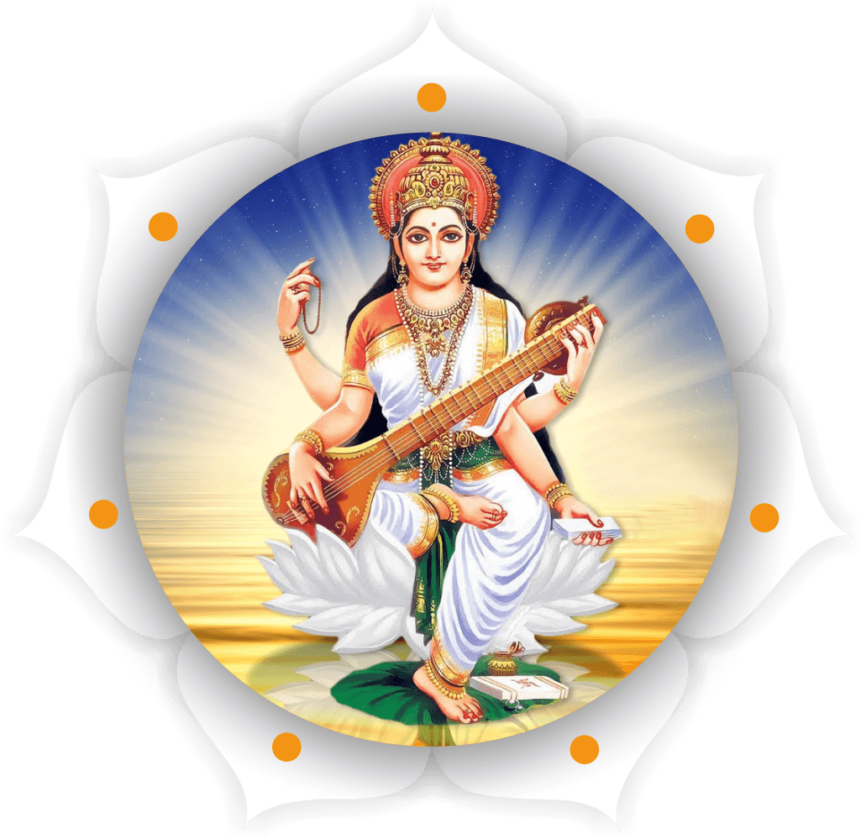
तमसो माँ ज्योतिर्गमय
MADHUBAN – MAU
PROJECT
ON
BIOLOGY
SESSION : 2023- 24

Submitted By | Supervision By
Name : | Mr. C.B. Rai
Class: 12 (B) | Department of Biology
Board Roll No :

